Course Allocation and Scheduling System


by
Awais ali
Supervised by
Dr. Ayaz Hussain

Department of Computer Science
Quaid-i-Azam University, Islamabad

AKNOWLEDGEMENT
I would like to express my sincere gratitude to all those who supported me during the completion of this project.
I am especially thankful to my supervisor, Dr. Ayaz Hussain, for their valuable guidance, encouragement, and constructive feedback throughout this work. Their support was instrumental in helping me stay focused and improve the quality of the project.
I would also like to thank the faculty of the Department of Computer Science, for providing a strong academic foundation and the resources needed to complete this work.
Special thanks to my friends and classmates for their cooperation and helpful suggestions, and to my family for their constant support and motivation.
This project would not have been possible without the contribution of all these individuals. I am truly grateful.

ABSTRACT
The Course Scheduling and Allocation System aims to automate and optimize the course allocation process to students and schedule best classes. In traditional schools, course allocation and timetabling are mostly done manually, are time-consuming, and prone to conflict such as overlapping of classes or in adequacy of space.
This system will assist in resolving these problems by offering a centralized forum through which students are enrolled into courses based on their study program, semester, and prerequisites. The system considers aspects such as availability of courses, instructor schedules, classroom capacity, and student preferences while assigning courses. The system automatically creates students' and faculty members' conflict-free schedules.
The answer is built upon modern web technologies and includes a database to manage course information, users, and schedules. The accuracy is enhanced, administrative workload reduced, and the experience of students and teaching staff improved. The system is particularly beneficial in universities and colleges where it is not viable to manage large quantities of course and scheduling information manually.

Contents
AKNOWLEDGEMENT 2
ABSTRACT 3
Software Project Management Plan 9
1.1 Introduction 10
1.2 Problem Definition 10
1.3 Motivation 10
1.6 Project Organization 10
1 Model 10
2 Roles and Responsibilities 11
3 Tools and Techniques 11
1.6.4 Project deliverables 11
1.7 Project Management plan 12
1 Task 12
2 Timetable 14
Software Requirements Specifications 15
1 Introduction 16
1.1 Purpose 16
1.2 Scope 16
1.3 Functionality 16
1.4 Stakeholder 16
1.5 Constraints 16
2 External Interface Requirements 16
2.1 User Interface 16
2.2 Hardware Interface 17
2.3 software Interface 17
3 Functional Requirements 17
3.1 Usecase List 17
3.2 Usecase Diagram 17
3.3 Usecase Description 18
1. Sign up 18
2. Sign in 19
4. View courses 20
5. Drop course 20
6. Allocate courses 21
7. Deallocate course 22
8. Generate timetable 22
9. View timetable 23
10. Delete timetable 23
11. Update timetable 24
12. Add class 25
13. Remove class 25
14. Log out 26
3.4 System Sequence Diagram 26
1. Sign in 27
2. Sign up 27
3. Register course 28
4. View course 28
5. Drop course 29
6. Allocate course 29
7. Deallocate course 30
8. Generate timetable 30
9. View timetable 31
10. Update timetable 31
11. Delete timetable 32
12. Add class 32
13. Remove class 33
14. Log out 33
4 Domain Model 34
5 Software System Attributes 34
5.1 Reliability 34
5.2 Availability 34
5.3 Security 34
5.4 Maintainability 34
5.5 Portability 34
5.6 Performance 35
6. Database requirement 35
6.1 Database name 35
6.2 Collections 35
6.3 Key field 35
Software Design Description 36
1. Introduction 37
1.1 Design Overview 37
1.2 Requirements Traceability Matrix 37
2. System Architecture Design 37
2.1 system Architecture 37
2.2 Alternative Designs 37
2.3 System Interface Discerption 38
3. Detail Discerption of component 38
3.1 Authentication Module 38
3.2 Course Registration Module 38
3.3 Course Allocation Module 38
3.4 Timetable Generation Module 38
3.5 Class Management Module 38
4. User Interface Design 38
4.1 Description of the User Interface 38
4.2 Screen Image 39
1. Sign in/Sign up 39
2. Student 40
3. Teacher 42
4. Admin 42
4.3 Object and action 43
5. Sequence Diagram 44
5.1 Sign in 44
5.2 Sign up 44
5.3 Register course 45
5.4 View course 45
5.5 Drop course 45
5.6 Allocate course 46
5.7 Deallocate course 46
5.8 Generate timetable 46
5.9 View timetable 47
5.10 Update timetable 47
5.11 Delete timetable 47
5.12 Add class 48
5.13 Remove class 48
5.14 Log out 48
6. Class Diagram 49
7. SwimLame Diagram 50
Software Test Documentation 51
1. Introduction 52
1.1 System Overview 52
1.2 Test Approach 52
2. Test Plan 52
2.1 Feature to be Tested 52
2.2 Features not to be Tested 52
2.3 Testing Tool and Environment 52
3. Test Cases 53
3.1 Sign in 53
3.2 Sign up 53
3.3 Register course 54
3.4 View course 54
3.5 Drop course 55
3.6 Allocate course 56
3.7 Deallocate course 57
3.8 Generate timetable 57
3.9 View timetable 58
3.10 Update timetable 58
3.11 Delete timetable 59
3.12 Add class 59
3.13 Remove class 59
3.14 Log out 60
Conclusion 61
1. OverView 62
2. Conclusion 62
3. Reference 62

Chapter 1

Software Project Management Plan

1.1 Introduction
The management of course allocation and schedule in educational institutions is a complex task, often leading to the conflict between classrooms, disabled resource use and student dissatisfaction. An automated course allocation and schedueling system solve these challenges and hand over the courses for time slots and rooms while avoiding conflicts. Using the adaptation algorithm, the system faculty ensures proper and efficient scheduling based on availability, student preferences and ability of the room. The project aims to develop a reliable solution that reduces manual effort, eliminates timetable skirmishes, and enhances educational experience for both students and administrators.

1.2 Problem Definition
Educational institutions manually face important challenges in management courses and the program, causing disability and disappointment for both students and administrators. The current system often consists of timetable clashes, where overlapping class schedule prevents students from enrolment in necessary or preferred courses. Additionally, classes are reduced less than poor resource allocation or overbooks, while faculty lacks availability becomes more complicated. These disabilities create administrative burden, as manual adjustments are time -taken and often fail to solve all conflicts. Students, in turn, experience dissatisfaction when they are forced to compromise their educational plans due to scheduling conflicts. To address these issues, an automated course allocation and scheduling system are required. Such a system will wisely provide courses, adapt to resource usage, and end scheduling conflicts, ensuring a comfortable and fair educational experience for all stakeholders. By taking advantage of algorithm solutions, this system will reduce manual efforts, improve efficiency, and increase overall satisfaction in course registration and scheduling processes.

1.3 Motivation
The current manual process of scheduling courses in universities often result in timetable conflict, disabled resource allocation and frustration for both students and faculty. Students struggle when the required courses overlap, which is forced to delay their educational progress, while administrators ruin the valuable time trying to manually resolve the scheduling issues. These challenges become more complicated as institutions expand the offerings of their course and increase student enrolment. An automated course allocation and scheduling system can solve these problems by intelligently assigning the classes for optimal time slots and rooms. By eliminating conflicts and optimizing resource usage, such a system will reduce administrative charge, ensure proper access to courses, and creates a smooth educational experience for all. The purpose of this project is to modernize the scheduling process, which is more efficient, transparent and student friendly.

1.6 Project Organization

1 Model
The project will follow Agile development methodology, which implements features through a repeated sprint. Development will prioritize the first core scheduling functionality, then will include additional facilities such as successive conflict solutions and adaptation. A product will guide the implementation process while maintaining flexibility to adapt the requirements to develop backlog. Regular progress assessment will ensure continuous improvement in the entire development life cycle.

2 Roles and Responsibilities
Role
My role is to develop a course allocation and scheduling system which will automatically solve the clashes generated a perfect timetable. I have to use algorithm in backend to solve the clashes.
Responsibilities:
Requirement Analysis: I must understand the user requirement for the start of the project.
Design: Creating the architecture, database schema, and UI/UX flow.
Development: Developing the project and implementing its feature.
Testing: Testing the features of the system and conducting the acceptance test.
Deployment: Deploying the system.
Maintenance: Fixing bugs and improving features post-launch.

3 Tools and Techniques
Tools | Purpose
Project Libre | Use to build project plan
Draw.io | Use to build SSD, use case and other diagrams
Mongo db | Use to store the data of course and timetable schedule
MS Word | Use for documentation
CSS,HTML,JavaScript | Use to design front end and backend
Vs code | Use for coding

1.6.4 Project deliverables
- Software Project Management Plan (SPMP).
- Software Requirement Specification (SRS).
- Software Design Description (SDD).
- Software Test Documentation (STD).
- The web application.

1.7 Project Management plan
This project management plan allocates the resources and schedules the activities. It also identifies the task that should be done.

1 Task
Task Name | Description | Deliverables | Resource | Dependencies and Constraints | Risk
Define the Scope and Boundary | The scope of the system and boundary for the system according to the requirement. | A proper understanding what our system will and will not do. | Ms word | Stake holder Requirement | If the system Scope will not be defined according to the requirement it may not fulfil the user need.
Select Process Model | The process Model describe the how system should be developed and deployed. | A perfect Model for the system. | Ms word | Depend upon different thing, requirement, delivery and future modification. | If we select model wrong model that doesn’t suitable for the project, it may cause delay in project delivery.
Role and Responsibilities | Assigning the role and responsibilities to the developers. | Role and Responsibilities. | Ms Word | Depend upon the skills of the developers. | Unskilled worker can cause the delay in project.
Tools and Techniqs | Selecting the Tools for the project and programming language. | A proper table of tools and technique. | Ms word | Depend upon what kind of system you need. | None
Project Management Plan | Create a proper management plan allocate the resource, time and milestone. | Schedule and timetable for project to complete in time duration. | Project Libre | Time duration and resources. | None
Requirement Analysis | The stake holder requirement is analysed to define the use case. | Understanding of requirement. | None | User requirement | If the developer didn’t understand the user requirement properly it may doesn’t satisfy the user.
Defining the UseCase Diagram | UseCase are the interaction of primary and secondary actor of the system. | UseCase diagram, | Draw.io | User requirement | Unwanted UseCase can cause delivery of unwanted feature.
UseCase Descriptions | Description which tells the stake holder interest, Alternate flow, requirement and success scenario etc. | Descriptions of UseCase. | Ms word | UseCase Diagram | Descriptions should be understood able, so the user can understand the purpose of system.
System Sequence Diagram | It shows the interaction between external actor and system. | SSD for each UseCase | Draw.io | UseCase Description | Incomplete UC  Misunderstood system boundaries  Actor  misidentification
Domain Model | It is a visual representation of conceptual classes. | UML Domain Model | Draw.io | UseCase model and requirements | Missing domain concepts  Confusing real-world classes  Ambiguous relationships
Class Diagram | It shows the system classes, attributes and relationship. | UML Class Diagram | Draw.io | Domain Model  UseCase | - Incorrect relationships  - Too much detail early
System Architecture | It defines the high-level structure of a software system. It describes how the system is organized into components. | System Architecture Diagram | Draw.io | Requirements Specification  Technology Decisions  Skills | Choosing the wrong architecture pattern
Design the User Interface | The user screen prototype is created, so user can how its system will look like. | User Screen design | Figma | UseCase  Requirements | None
Acceptance tests | It validates the system from the user’s perspective. | Acceptance Test Plan  Test Cases with Pass/Fail results | Ms Word | UseCase | Test cases may not cover all user expectations, leading to rejection.
Implementation | A proper system is developed using coding. | System | CSS  HTML  JavaScript | Documentation | If there is a problem in documentation, then that can cause a system delivery that doesn’t satisfy the User.

2 Timetable
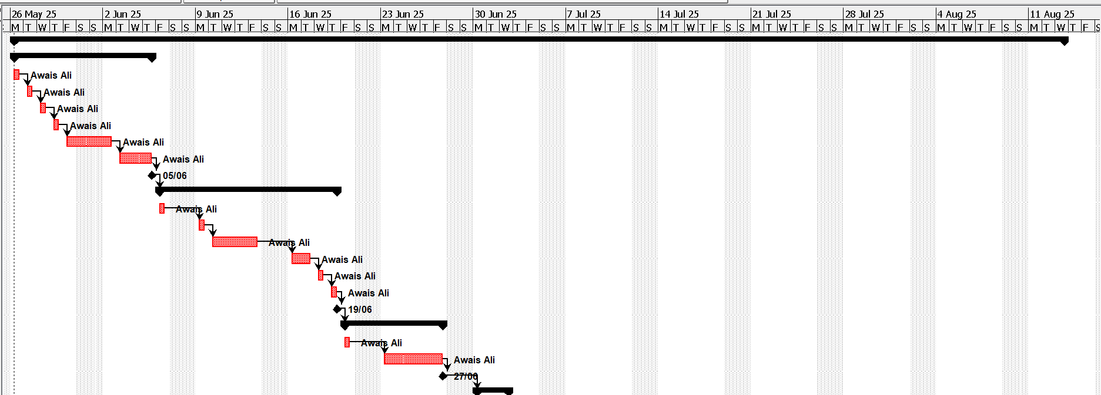
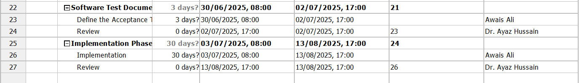
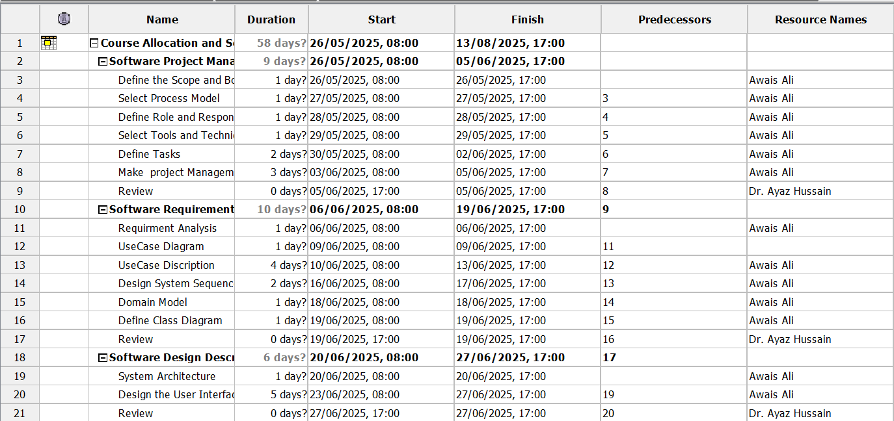

Chapter 2

Software Requirements Specifications

1 Introduction

1.1 Purpose
This system automated the course allocation and scheduling for students, faculty and administrators. This automatically eliminates the course conflict, allowing students to register for courses. The faculty can specify your favourite courses to teach, and the algorithm of the system will assign them based on room availability and scheduling obstacles. Wise allocation ensures optimal resource usage for all users while maintaining a struggle-free timetable.

1.2 Scope
This system automatic the course scheduling to avoid timetable clashes. It provides classes for available rooms and allows students to register without conflict. Teachers can choose preferred courses, and the system assigns them properly. Educational schedules and reports can be seen but cannot struggle manually. The system only handles the course scheduling.

1.3 Functionality
- It will allow the student to register their courses.
- Student can view their courses using it.
- Student can also the drop courses.
- It will allow the user to view the schedule of courses.
Administration can generate the schedule of the courses.
- Administration also can modify the schedule.
Administration can delete the schedule.

1.4 Stakeholder
- Student
- Teacher
- Admin

1.5 Constraints
- Must fallow the university policies so there will be no workload to the faculty.
- There can be some unresolved able conflict of courses.
- Must support web-based access.
- The devices should be connected to the network.

2 External Interface Requirements

2.1 User Interface
- The system will provide a web-based interface accessible through the browser.
- Specific dashboard for student to register courses, for teacher to view timetable and for administration to generate timetable.
- Easy to use web-based application for each stakeholder.

2.2 Hardware Interface
- Must run on the existing system operating system of university.
- Support the standard pc and laptops.

2.3 software Interface
- Support window Windows 10+ and mac.
- It should be integrated with database.
2.4 Communication protocols

3 Functional Requirements

3.1 Usecase List
- Sign in
- Sign up
- Register course
- View course
- Drop course
- Allocate course
- Deallocate course
- Generate timetable
- View timetable
- Update timetable
- Delete timetable
- Add class
- Remove class
- Log out

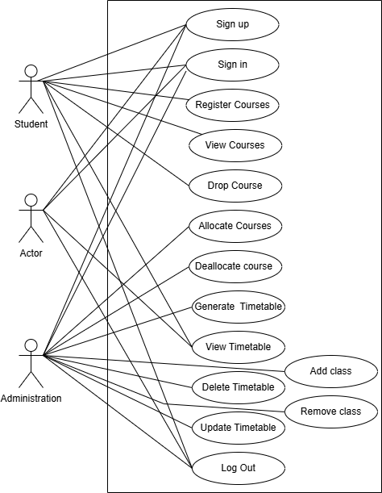
3.2 Usecase Diagram

Figure 1: Usecase diagram

3.3 Usecase Description
1. Sign up
The system will provide the functionality of Sign up and create a new account.
USECASE ID | UC-1
USECASE NAME | Sign up
PRIMARY ACTOR | - Teacher  - Student  - Administration
STAKE HOLDER AND INTEREST | Teacher/Student/Administration: The stakeholder is interested in creating an account.
PRECONDITION | - The stakeholder has access to the form for the sign up.  - Stakeholder is not already registered.
POST CONDITION | - The system stores the information of the stakeholder.  - User account is created.
INPUT | Stakeholder input data to create account:  - First Name  - Last Name  - Registration no  - Email  - Phone No  - Password
OUTPUT | System will give response “Account created successfully”.
MAIN SUCCESS SCENARIO (BASIC FLOW) | - The user selects the option to create account.  - The user will fill the information form to create account.  - The user select option to sign up.  - The system display message “Account created successfully”
ALTERNATE FLOW (EXTENSION) | A: Mandatory field no fill:  If the user doesn’t fill any important information: The system will display a message “Mandatory field not filled”.  B: Already have an account:  If the user enters the information that should be unique, and it already exist in record (email etc.): The system will display a message “Already have an account”.
SPECIAL REQUIREMENT | None
FREQUENCY OF USE | Moderate
SPECIAL ISSUE | None

2. Sign in
The system Will provide the functionality of sign in to the register account.
USECASE ID | UC-2
USECASE NAME | Sign in
PRIMARY ACTOR | - Teacher  - Student  - Administration
STAKE HOLDER AND INTEREST | Teacher/Student/Administration: The stakeholder is interested in sign in his account.
PRECONDITION | The user has created account into the system.
POST CONDITION | The user will be sign in to the account and the “Home page” will be displayed.
INPUT | - Stakeholder input data to create account:  - Registration no  - Password
OUTPUT | User will be logged in and the main interface of the system will be displayed to the user.
MAIN SUCCESS SCENARIO (BASIC FLOW) | 1. The user navigates to the sign-in section of the system.  2. The user enter the registration no and password.  3. The user submits the sign-in credentials to the system.  4. Sign-in credentials are verified by the system.  5. If user credentials are verified successfully then user will be logged into the system.
ALTERNATE FLOW (EXTENSION) | A: User account does not exist: If the user enters a user id which does not exist in the system, then the system displays a message “Invalid user credentials”.  B: Invalid password: If the user enters a user id which exists in the system but enters a wrong password for an account then the system displays a message “Invalid user password! Please try again!”.
SPECIAL REQUIREMENT | None
FREQUENCY OF USE | Moderate
SPECIAL ISSUE | None

3. Register courses
The system will allow the student to register the courses.
USECASE ID | UC-3
USECASE NAME | Register courses
PRIMARY ACTOR | Student
STAKE HOLDER AND INTEREST | Student: The student is interested in registering courses for the semester.
PRECONDITION | The student has a valid account and is signed in.
POST CONDITION | The student register courses will be saved on database.
INPUT | Course code
OUTPUT | - The system will start displaying registered courses successfully.  - The registered courses will be displayed on the screen, and student will be able to view the courses.
MAIN SUCCESS SCENARIO (BASIC FLOW) | - The student will select the option to register courses.  - The student will add the courses in form.  - The student will select the option to resister after entering courses.  - The system will display “Register courses Successfully”.  - The system will display registered courses on the screen.
ALTERNATE FLOW (EXTENSION) | A: Invalid Course Code: If the user entered the wrong course code the system will displaying “wrong course code entered”.
SPECIAL REQUIREMENT | None
FREQUENCY OF USE | Moderate
SPECIAL ISSUE | None

4. View courses
The student able to view the registered courses.
USECASE ID | UC-4
USECASE NAME | View courses
PRIMARY ACTOR | Student
STAKE HOLDER AND INTEREST | Student: The student is interested in viewing the register courses.
PRECONDITION | The student has registered courses.
POST CONDITION | The system will display registered courses.
INPUT | None
OUTPUT | The system will display list of registered courses.
MAIN SUCCESS SCENARIO (BASIC FLOW) | - The student will select the option to view course.  - The list of registered courses will be displayed.
ALTERNATE FLOW (EXTENSION) | None
SPECIAL REQUIREMENT | None
FREQUENCY OF USE | Moderate
SPECIAL ISSUE | None

5. Drop course
The student will be allowed to drop any courses using system
USECASE ID | UC-5
USECASE NAME | Drop course
PRIMARY ACTOR | Student
STAKE HOLDER AND INTEREST | Student: The student is interested in dropping the course.
PRECONDITION | The student has registered courses.
POST CONDITION | The system will update the courses information on the database against that specific student.
INPUT | Course code
OUTPUT | The system will display list of updated registered courses.
MAIN SUCCESS SCENARIO (BASIC FLOW) | - The student will select the option to drop courses.  - The student will enter the course code.  - The student will select the option to drop it.  - The conformation dialog box will be displayed.  - The system will display “updated register courses on the screen”.
ALTERNATE FLOW (EXTENSION) | A: Invalid Course Code: If the user entered the wrong course code the system will displaying “wrong course code entered”.
SPECIAL REQUIREMENT | None
FREQUENCY OF USE | Moderate
SPECIAL ISSUE | None

6. Allocate courses
The system will have functionality of allocate the courses to the teacher.
USECASE ID | UC-6
USECASE NAME | Allocate courses
PRIMARY ACTOR | Administration
STAKE HOLDER AND INTEREST | Administration: The administration is interested in allocating the courses to the teachers.
PRECONDITION | The user is sign in through an administration account.
POST CONDITION | The system will store the allocated courses details on the database.
INPUT | - Couse code  - Course Name  - Teacher id  - Teacher name  - Semester
OUTPUT | The system will display “allocated the courses successfully”.
MAIN SUCCESS SCENARIO (BASIC FLOW) | - The user will select option to allocate the courses.  - The allocation form will be displayed.  - The user enters the details for course allocation.  - The user select option to allocate courses.  - The system will display “allocated the course successfully”.
ALTERNATE FLOW (EXTENSION) | A: Invalid Course Code: If the user entered the wrong course code the system will displaying “wrong course code entered”.
SPECIAL REQUIREMENT | None
FREQUENCY OF USE | Moderate
SPECIAL ISSUE | None

7. Deallocate course
The system will have functionality of deallocate the course to the teacher.
USECASE ID | UC-7
USECASE NAME | Deallocate course
PRIMARY ACTOR | Administration
STAKE HOLDER AND INTEREST | Administration: The administration is interested in deallocating the courses to the teachers.
PRECONDITION | The courses will be allocated to the teachers.
POST CONDITION | The system will store the updated allocated courses details on the database.
INPUT | - Couse code  - Teacher name
OUTPUT | The system will display “deallocated the courses successfully”.
MAIN SUCCESS SCENARIO (BASIC FLOW) | - The list of allocated courses will be displaying to the teacher.  - The user will select option to deallocate the course.  - The system will ask for confirmation.  - The system will display “deallocated the course successfully”.
ALTERNATE FLOW (EXTENSION) | A: User selected the wrong course: if the user selects a wrong course and teacher for deallocation, it can cancel the deallocation during confirmation.
SPECIAL REQUIREMENT | None
FREQUENCY OF USE | Moderate
SPECIAL ISSUE | None

8. Generate timetable
The system will have functionality of allocate the courses to the teacher.
USECASE ID | UC-8
USECASE NAME | Generate timetable
PRIMARY ACTOR | Administration
STAKE HOLDER AND INTEREST | Administration: The administration is interested in generating schedule for courses.
PRECONDITION | - The whole student must register all courses they are studying.  - The admin allocated the courser to all teachers.  - The detail is stored on database
POST CONDITION | The system will store the schedule for courses on the database with minimal clashes.
INPUT | - Registered courses by each student.  - Allocated courses to each teacher.  - List of available classes.
OUTPUT | The system will display “Generated the schedule successfully”.
MAIN SUCCESS SCENARIO (BASIC FLOW) | - The user will select option to generate schedule for the courses.  - The system will automatically generate the schedule.  - The system will store the schedule on database.  - The system will display “generated the course schedule successfully”.
ALTERNATE FLOW (EXTENSION) | A: unresolve able clashes: There can be some unresolve able system will give the schedule with minimal clashes and list of unresolve able clashes.
SPECIAL REQUIREMENT | None
FREQUENCY OF USE | Moderate
SPECIAL ISSUE | None

9. View timetable
The system will have functionality of displaying schedule for courses.
USECASE ID | UC-9
USECASE NAME | View timetable
PRIMARY ACTOR | - Student  - Administration  - Teacher
STAKE HOLDER AND INTEREST | Stakeholder: The user is interested in viewing schedule for classes.
PRECONDITION | - The schedule for courses is already generated.
POST CONDITION | The system will display the timetable of classes.
INPUT | None
OUTPUT | The timetable for the classes will be displayed on screen.
MAIN SUCCESS SCENARIO (BASIC FLOW) | - The user select option to view timetable  - The system will display the schedule of the classes.
ALTERNATE FLOW (EXTENSION) | A: Selecting Wrong option: if the user selects the wrong option may it will take it to the wrong interface.
SPECIAL REQUIREMENT | None
FREQUENCY OF USE | Moderate
SPECIAL ISSUE | None

10. Delete timetable
The system will have functionality of deleting timetable.
USECASE ID | UC-10
USECASE NAME | Delete timetable
PRIMARY ACTOR | Administration
STAKE HOLDER AND INTEREST | Administration: The user is interested in deleting timetable.
PRECONDITION | The schedule for courses is already generated.
POST CONDITION | The system will delete the timetable and update the database.
INPUT | Timetable
OUTPUT | The system will display the “Timetable is deleted”.
MAIN SUCCESS SCENARIO (BASIC FLOW) | - The user select option to delete the time timetable.  - The system will update the database and remove the timetable.  - The system will display “deleted the timetable successfully”.
ALTERNATE FLOW (EXTENSION) | A: Selecting Wrong option: if the user selects the wrong option may it will take it to the wrong interface.
SPECIAL REQUIREMENT | None
FREQUENCY OF USE | Moderate
SPECIAL ISSUE | None

11. Update timetable
The system will have functionality of Updating the timetable details.
USECASE ID | UC-11
USECASE NAME | Update timetable
PRIMARY ACTOR | Administration
STAKE HOLDER AND INTEREST | Administration: The user is interested in updating the timetable details.
PRECONDITION | The schedule for courses is already generated.
POST CONDITION | The system will update the timetable details on database.
INPUT | - Course code  - Class no  - Teacher name
OUTPUT | The system will display the “Timetable is updated”.
MAIN SUCCESS SCENARIO (BASIC FLOW) | - The user select option to update the time timetable.  - The system will update the database and add new timetable.  - The system will display “updated the timetable successfully”.
ALTERNATE FLOW (EXTENSION) | A: Entering wrong information: If the user enter the wrong information in wrong field, then the system will display “Invalid information added”.
SPECIAL REQUIREMENT | None
FREQUENCY OF USE | Moderate
SPECIAL ISSUE | None

12. Add class
The system will allow the administration to add a class in class list.
USECASE ID | UC-12
USECASE NAME | Add class
PRIMARY ACTOR | Administration
STAKE HOLDER AND INTEREST | stakeholder: The user is interested in adding available classes for courses.
PRECONDITION | The user must be sign in to the account.
POST CONDITION | The system will update the database and add a class in it.
INPUT | Class No
OUTPUT | The system will display message “class added successfully”.
MAIN SUCCESS SCENARIO (BASIC FLOW) | - The user select option to add a class  - The user will enter the class no in the field.  - The system will ask for confirmation.  - The system will add the class on database.  - The system will display “class added successfully”.
ALTERNATE FLOW (EXTENSION) | A: Cancelling the process: if the user, during confirmation select the option to cancel the process, then the class will not be added to the classes list.
SPECIAL REQUIREMENT | None
FREQUENCY OF USE | Moderate
SPECIAL ISSUE | None

13. Remove class
The system will allow the administration to remove a class from class list.
USECASE ID | UC-13
USECASE NAME | remove class
PRIMARY ACTOR | Administration
STAKE HOLDER AND INTEREST | stakeholder: The user is interested in removing the class from classes list.
PRECONDITION | There should be one or more classes added to class list.
POST CONDITION | The system will update the database and remove class form class list.
INPUT | Class No
OUTPUT | The system will display message “class removed successfully”.
MAIN SUCCESS SCENARIO (BASIC FLOW) | - The user selects intended class that he wants to remove.  - The select option to remove the class.  - The system will ask for confirmation.  - The system will update the classes on database.  - The system will display “class removed successfully”.
ALTERNATE FLOW (EXTENSION) | A: Cancelling the process: if the user, during confirmation select the option to cancel the process, then the class will not be remove from classes list.
SPECIAL REQUIREMENT | None
FREQUENCY OF USE | Moderate
SPECIAL ISSUE | None

14. Log out
The system will allow the user to log out from the account.
USECASE ID | UC-12
USECASE NAME | Log out
PRIMARY ACTOR | - Student  - Administration  - Teacher
STAKE HOLDER AND INTEREST | stakeholder: The user is interested in logging out from the account.
PRECONDITION | The user must be sign in to the account.
POST CONDITION | The system will navigate to the sign in page.
INPUT | None
OUTPUT | The system will navigate to the sign in page.
MAIN SUCCESS SCENARIO (BASIC FLOW) | - The user select option to log out.  - The system will remove sign-in information of the user.  - The system will ask for confirmation of log out.  - The user will navigate to the sign-in page.
ALTERNATE FLOW (EXTENSION) | A: Cancelling the process: if the user, during confirmation select the option to cancel the log-out process, then the user will not be log-out from the system.
SPECIAL REQUIREMENT | None
FREQUENCY OF USE | Moderate
SPECIAL ISSUE | None

3.4 System Sequence Diagram
It is used to show interaction between the system and user. How the functionality will work.

Sign in
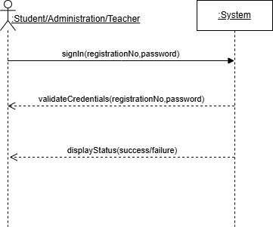

Sign up
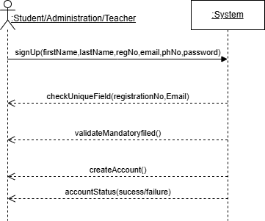

Register course
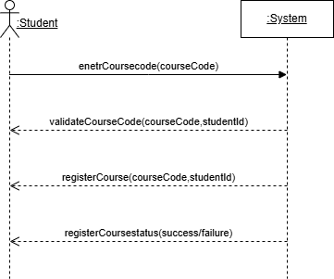

View course
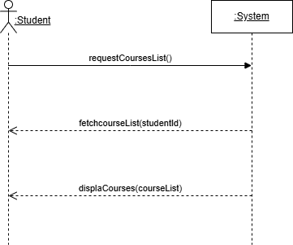

Drop course
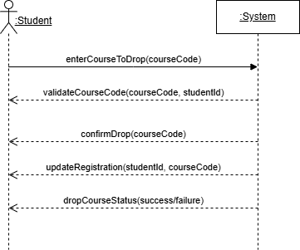

Allocate course
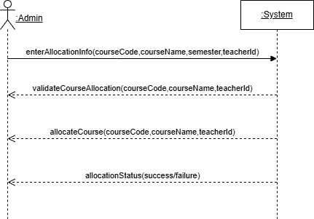

Deallocate course
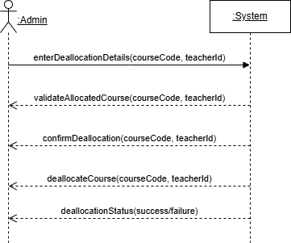

Generate timetable
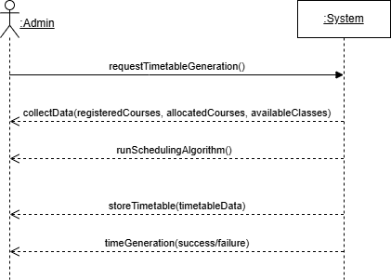

View timetable
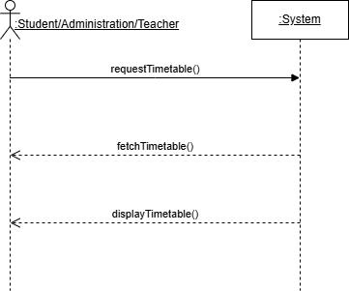

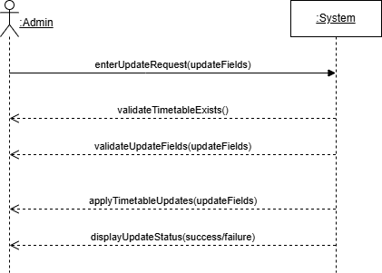
Update timetable

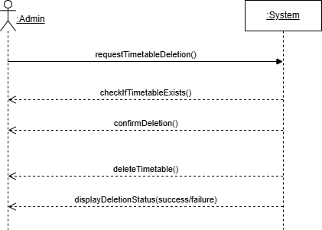
Delete timetable

Add class
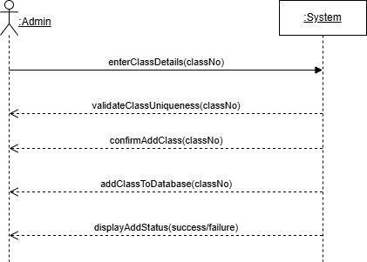

Remove class
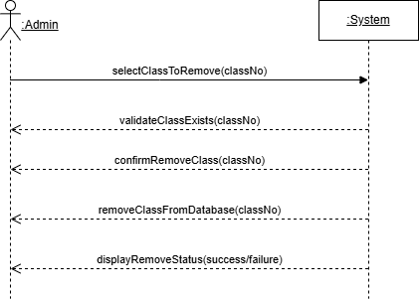

Log out
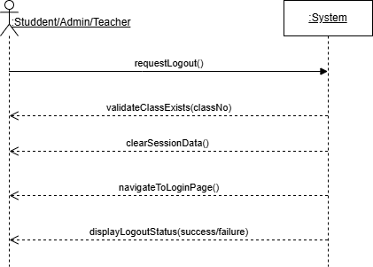

4 Domain Model
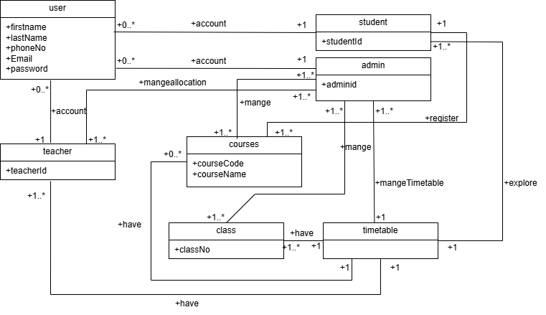

5 Software System Attributes

5.1 Reliability
The system will reliably manage the course allocation and scheduling. The validation will ensure that the system behaviour remains correct under normal and exceptional circumstances.

5.2 Availability
The system will be accessible to all user during the academic period. Web based applications make ensure that everyone can access the application, when they are connected to the internet.

5.3 Security
The system will ensure that authentication using login information and enforce the access control for student, faculty and administration. Sensitive operation, like timetable generation, allocation of courses will be accessible to authorized users.

5.4 Maintainability
The system will be constructed using MVC architecture and modular approach, well-documented code. Future updates can be made with little interruption, such as adding support for new features or repairing bugs. Error tracking tools and log files will help identify and fix problems.

5.5 Portability
Being a web-based solution means it will work with the main operating systems (Windows, macOS, Linux) and accessed through a modern web browser (Chrome, Firefox, Edge - to name a few). Backend components can be deployed on any server that supports Node.js and MongoDB.

5.6 Performance
System will be architected to manage multiple users concurrently (e.g., for instance, registration peaks). Database indexing, query optimization, and pagination will provide for rapid response times for operations such as course lookup, registration, and timetable generation.

6. Database requirement
The system will use MongoDB database to store, retrieve and manage all data. The database must fulfil the following requirement:

6.1 Database name
CourseSchedulingDB

6.2 Collections
users | Stores user information (Students, Teachers, Admins).
courses | Stores the course code and course name.
registrations | Stores the student course registration details.
allocations | Stores which teacher is assigned to which course.
classes | Stores available classrooms and their details (room number).
timetable | Stores the timetable.

6.3 Key field
Use of indexes on key fields:
- registrationNo, email in users
- courseId, studentId in registrations
- teacherId in allocations
Support for query filters, pagination, and sort operations on listings

Chapter 3

Software Design Description

1. Introduction

1.1 Design Overview
The system is intended to automate course registration, allocation, and timetabling. It partitions the interface, logic, and data layers according to the MVC (Model-View-Controller) pattern. The main features are student registration, teacher-course assignment, class creation, and automatic generation of timetables based on backend algorithms that avoid conflicts.
1.2 Requirements Traceability Matrix
Requirement ID | Description | Component
R1 | Sign in/Sign up | Authentication Module
R2 | Register/Drop Course | Course Registration Module
R3 | Allocate/Deallocate Courses | Course Allocation Module
R4 | Generate/View/Update/Delete Timetable | Timetable Generation Module
R5 | Add/Remove Classrooms | Class Management Module

2. System Architecture Design
2.1 system Architecture
The system is using Model View Controller (MVC) Architecture:
Model: The system uses MongoDB Model to store the class, Allocation, registration of courses and user information.
View: The view is interfaces for user, admin and Teacher.
Controller: The controller handles the validation of data, user request and system logic.
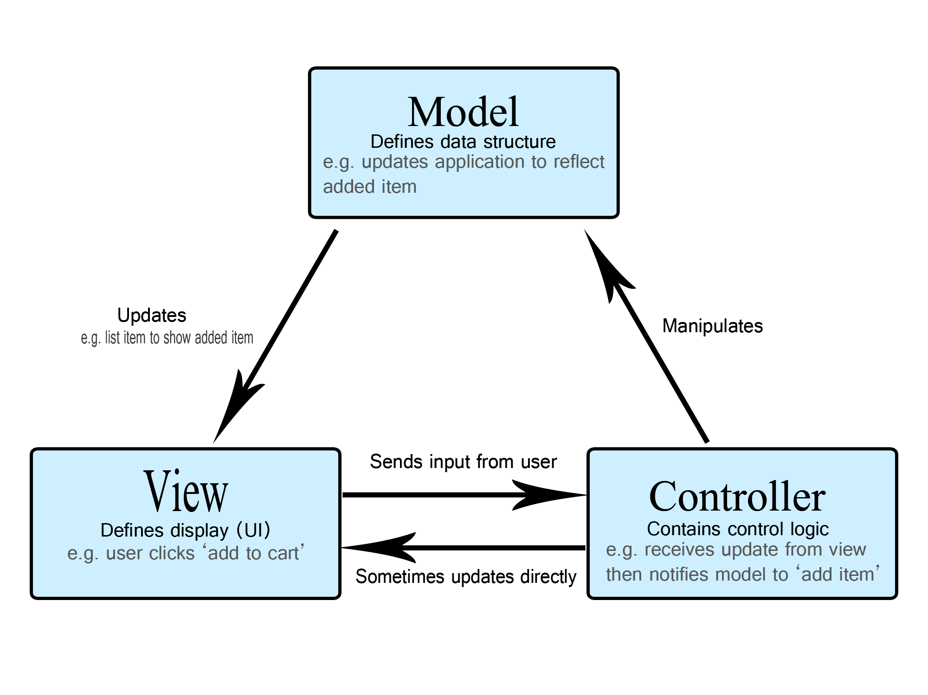
2.2 Alternative Designs
Monolithic Architecture: A traditional approach where an entire application is built as a single, integrated unit. It's like a single, large piece of code that performs all the necessary functions.
It is not suitable due to future scalability concerns.
Microservices Architecture: Microservices architecture is a method of designing software applications as a collection of small, independent, and loosely coupled services. Each service is responsible for a specific business function.
It is not suitable due to high complexity.

2.3 System Interface Discerption
Frontend: The frontend design using CSS, HTML and JavaScript.
Backend: The Node JS and Express JS is used for backend.
Database: MongoDB will be used for storing data.

3. Detail Discerption of component

3.1 Authentication Module
It will manage the user registration sing in, sign up and session control for log out. It allows users to access according to their role. If the user is a student, then there will be specific option that will be available to the student, and it will allow the user to access feature according to their role (student, Teacher and admin).

3.2 Course Registration Module
This Module have functionality of register course and drop course. It will help in preventing the conflicts between courses of timetable. It will help in generating the timetable. The students can register and drop a course.

3.3 Course Allocation Module
It will mange allocation and deallocation of courses to the teachers. It will allow the admin to allocate the course to the teacher if that teacher is interested and available.

3.4 Timetable Generation Module
It will generate schedule automatically based on register courses by students, availability of classrooms and allocation of courses for the teachers. It will allow the admin update and delete schedule.

3.5 Class Management Module
Supports the Add Class and Remove Class functionalities. Admins can add new classrooms and remove existing ones from the system. Interacts with the timetable module to ensure only available classes are used in scheduling.

4. User Interface Design

4.1 Description of the User Interface
Student Dashboard: It will allow student to register course, drop course and view timetable.
Teacher Dashboard: It will allow teacher to view timetable.
Admin Dashboard: It will allow admin to allocate/deallocate course to teacher, Add/Remove class and update/Delete/ generate and view schedule.

4.2 Screen Image
These screens are just prototype there can be change while creating a web application.

1. Sign in/Sign up
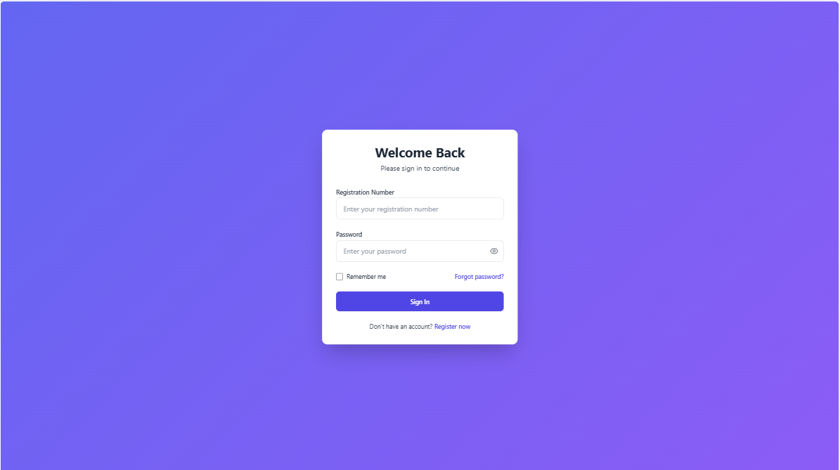

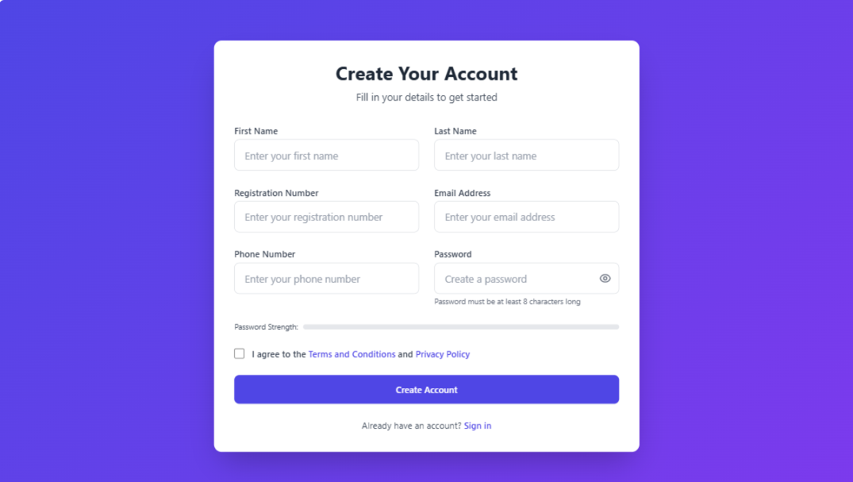

2. Student
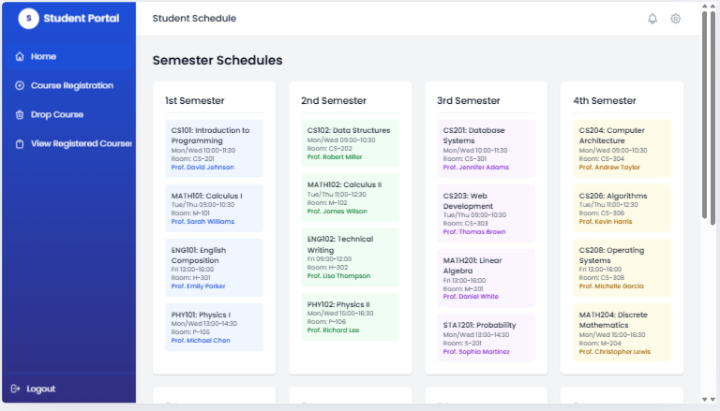

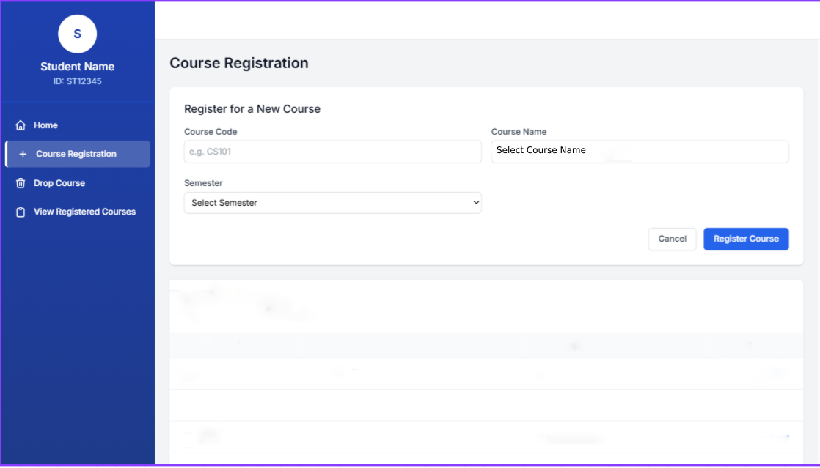

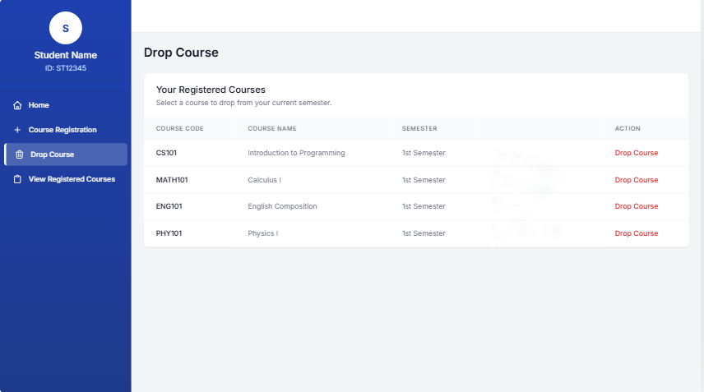

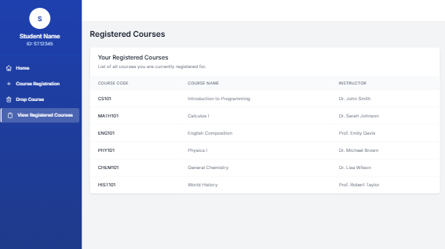

3. Teacher
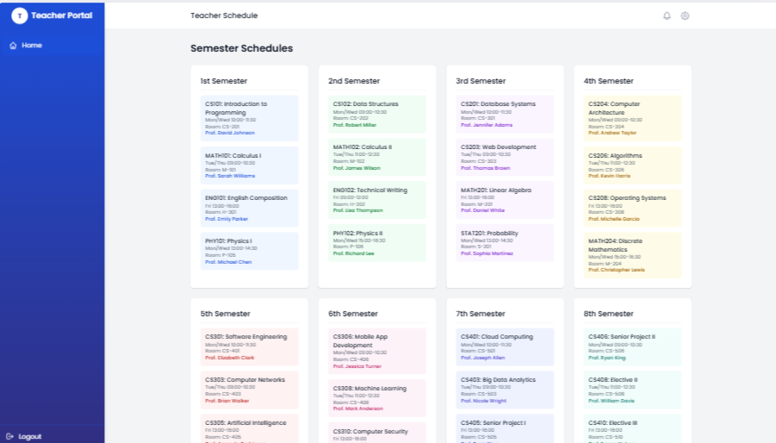

4. Admin
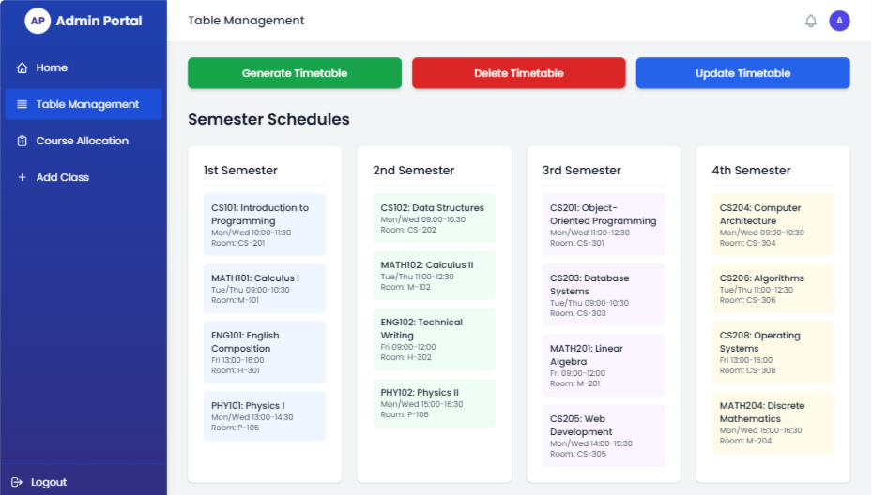

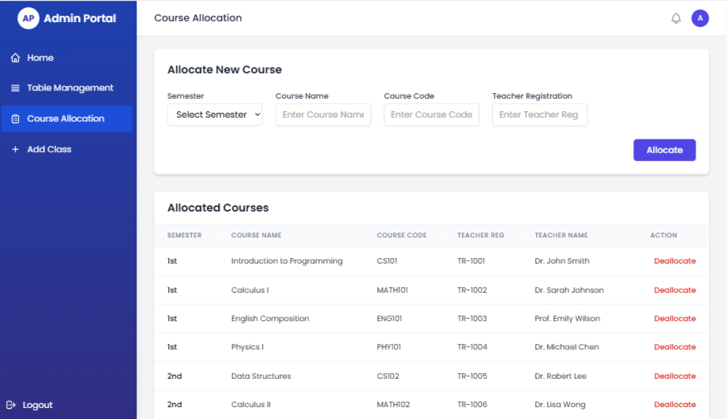

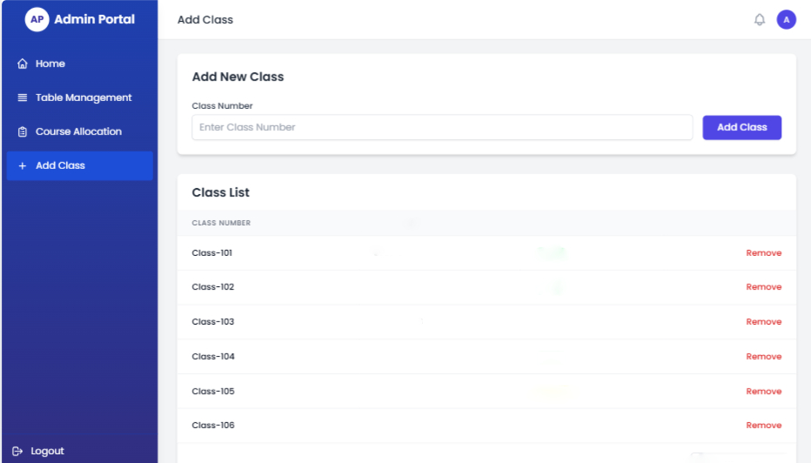

4.3 Object and action
Object | Action
Sign up | Allow user to create account
Sign in | Allow the user sign in to his account
Register Course | Allow Student to register course
Drop Course | Allow student to drop course
Allocate Course | Allow admin to allocate course to the teacher
Deallocate Course | Allow admin to deallocate the allocated course to teacher
Generate Schedule | Generate schedule for classes automatically
Delete Schedule | Delete the generated schedule
Update Schedule | Update the existing schedule
Add Class | Add a new class that is available
Remove class | Remove a class from list
View Schedule | View schedule that is generated by teacher
Log out | End the session

5. Sequence Diagram

5.1 Sign in
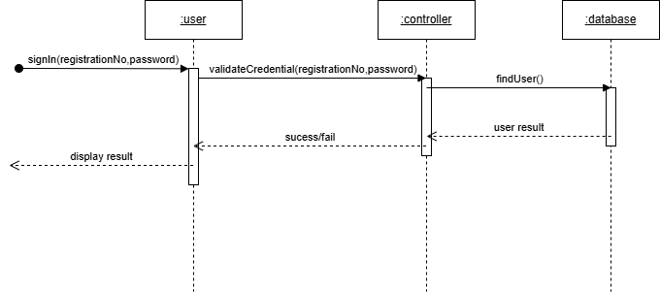

5.2 Sign up
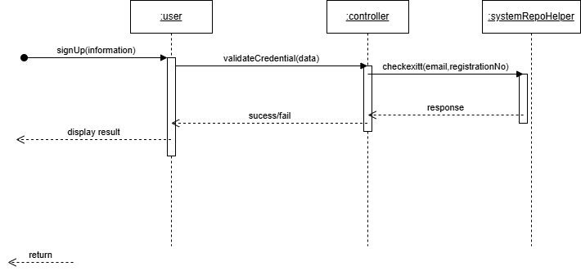

5.3 Register course
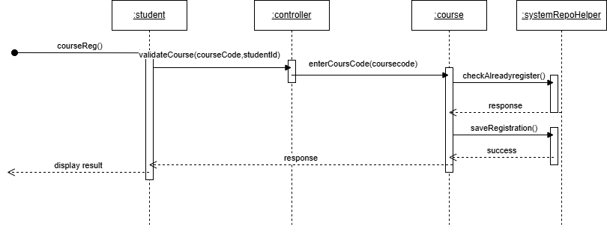

5.4 View course
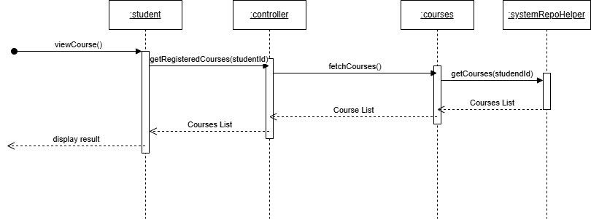

5.5 Drop course
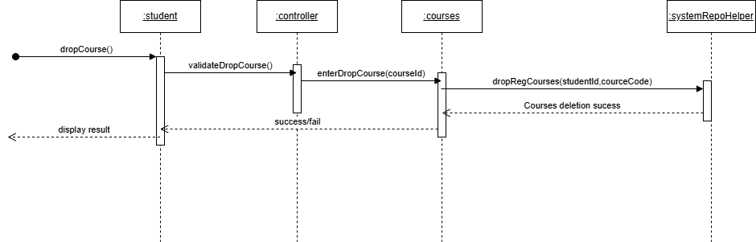

5.6 Allocate course
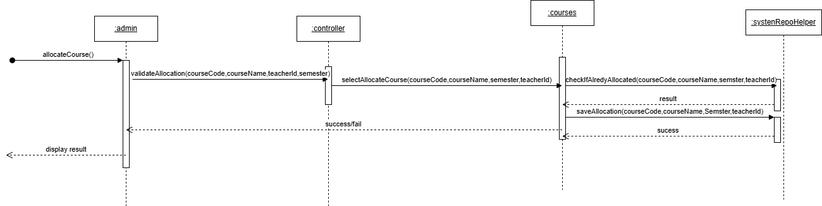

5.7 Deallocate course
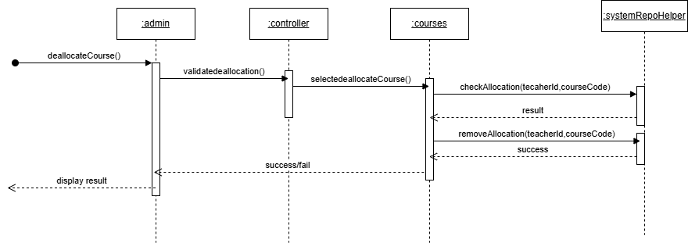

5.8 Generate timetable
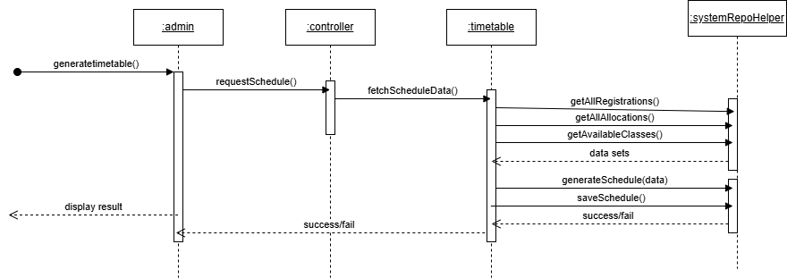

5.9 View timetable
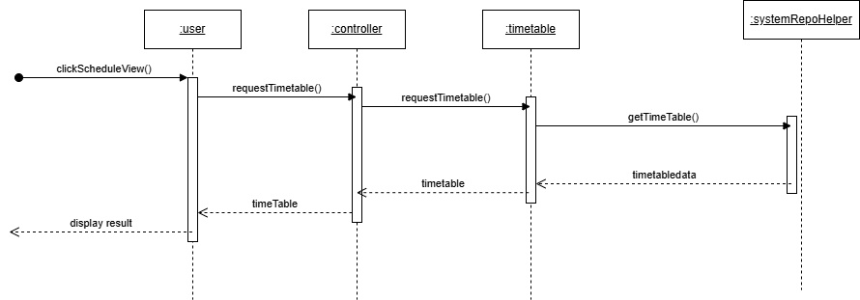
:user

5.10 Update timetable
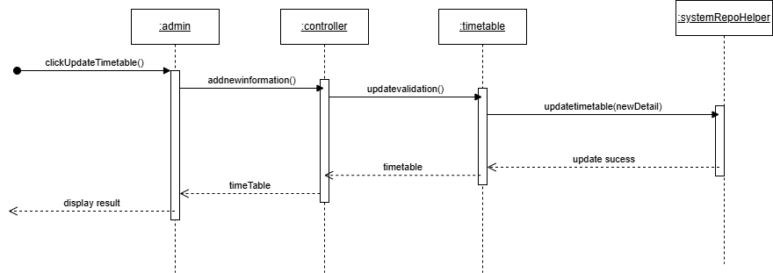

5.11 Delete timetable
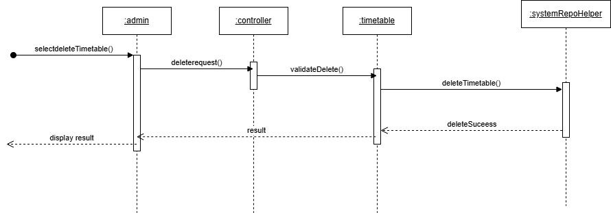

5.12 Add class
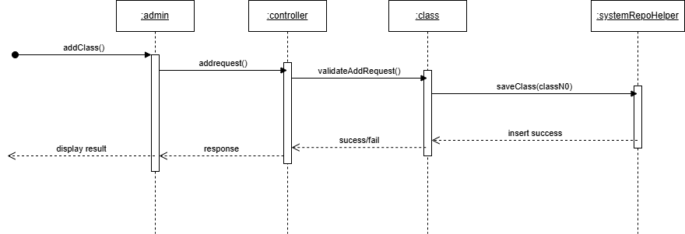

5.13 Remove class
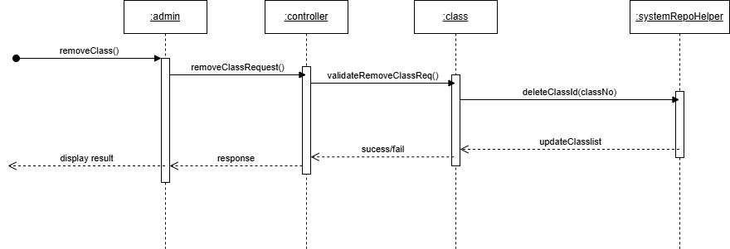

5.14 Log out
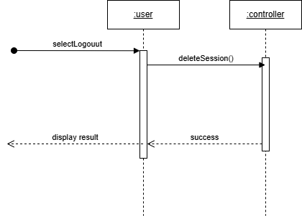

6. Class Diagram
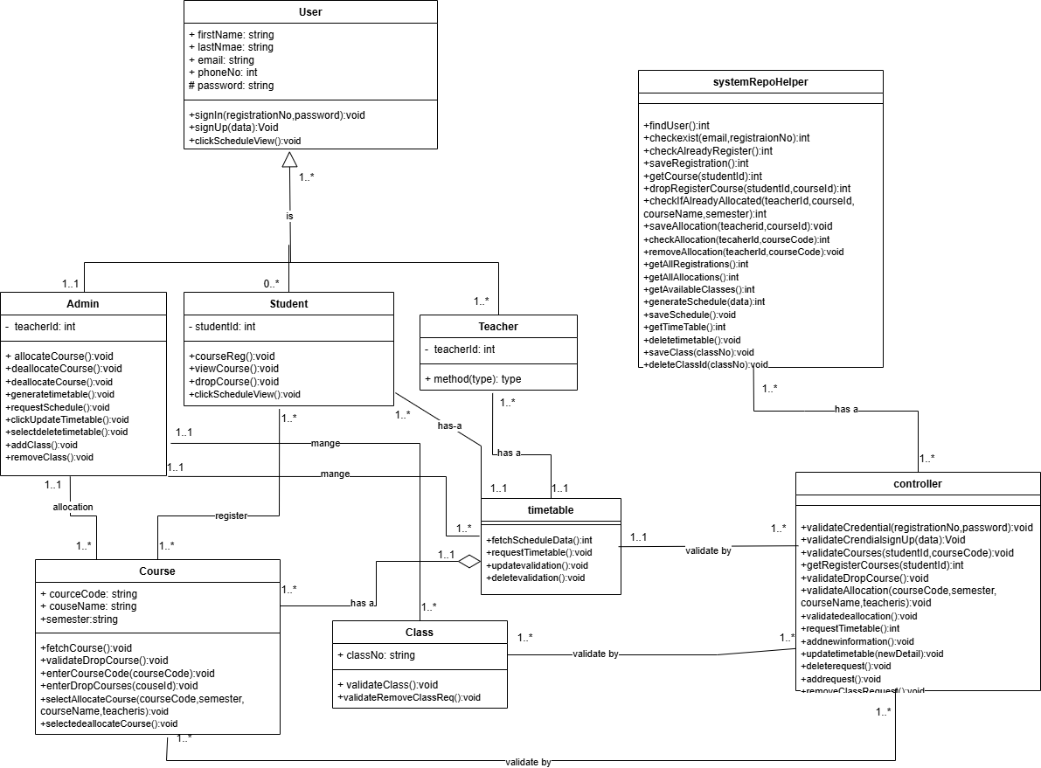

7. Swimlane diagram
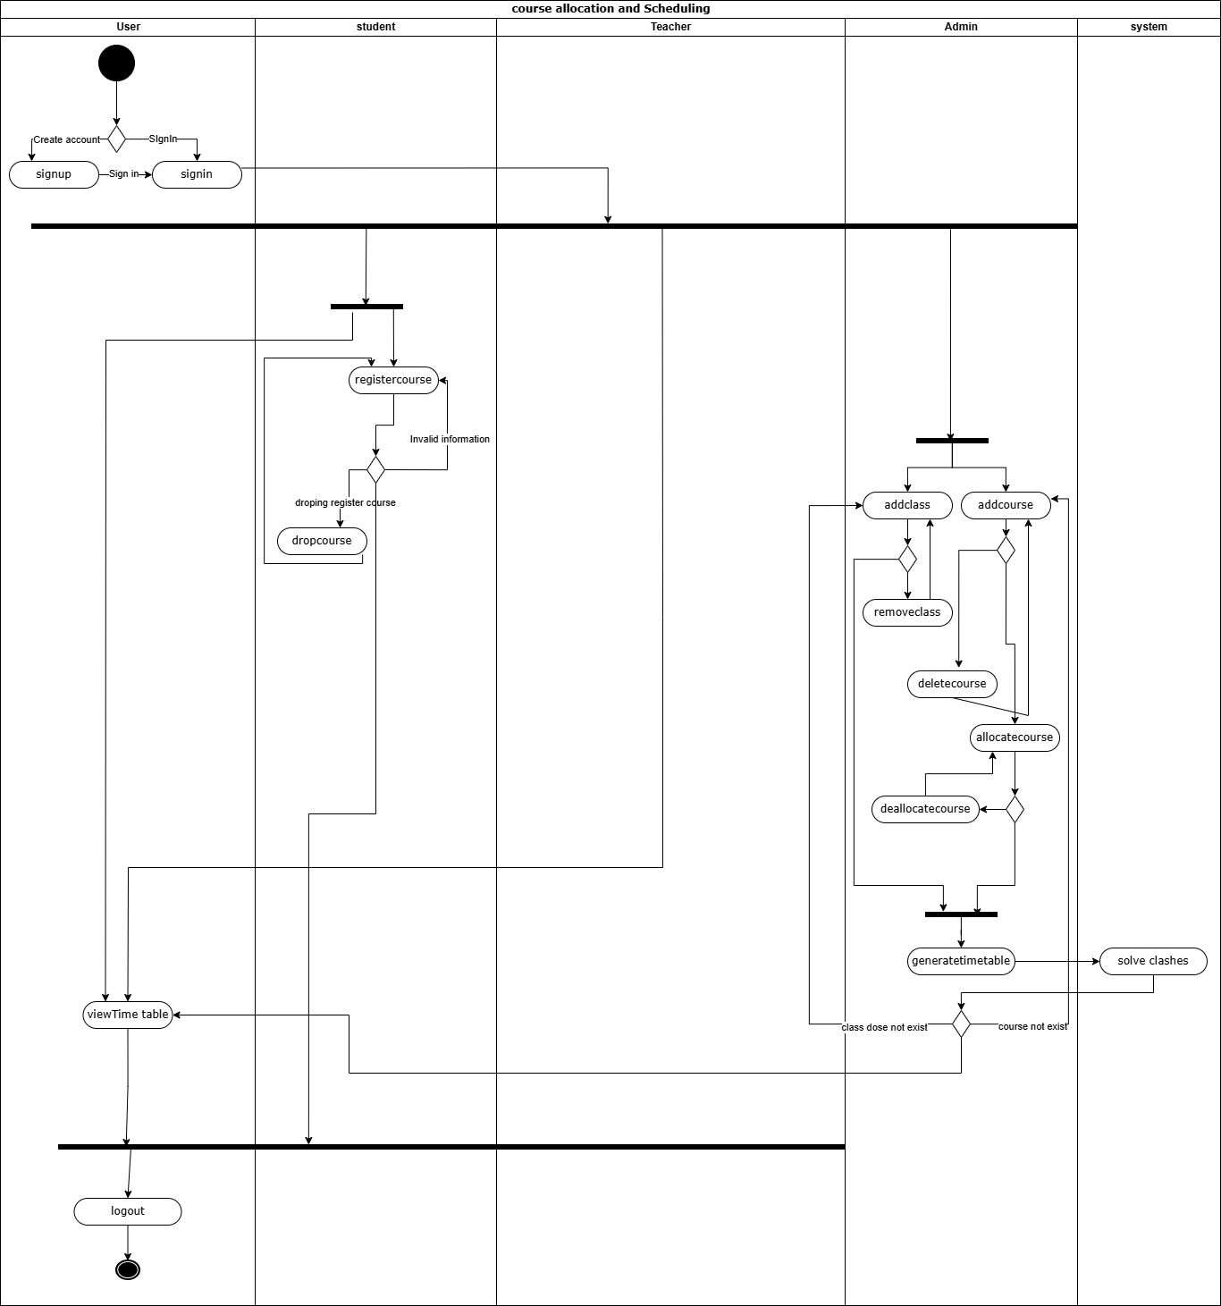

Chapter 3

Software Test Documentation

1. Introduction

1.1 System Overview
The course allocation and scheduling system is Web based application. It is developed using NodeJS, Express and MongoDB. The front-end is developed using traditional HTML, CSS and JavaScript. It automates the course allocation, Class Management, registration, generation of timetable and management. It also minimizes the clashes between courses.

1.2 Test Approach
Testing will focus on verifying each module: authentication, registration, course allocation, timetable generation, and class management. Both functional will be tested manual test execution and web browser tool.
2. Test Plan

2.1 Feature to be Tested
These functionalities should be tested:
- Sign in
- Sign up
- Register course
- View course
- Drop course
- Allocate course
- Deallocate course
- Generate timetable
- View timetable
- Update timetable
- Delete timetable
- Add class
- Remove class
- Log out

2.2 Features not to be Tested
- MongoDB performance
- Browser compatibility beyond Chrome and Firefox

2.3 Testing Tool and Environment
Environment: Local Host, Node.js server, MongoDB database
Tools: Postman, Visual Studio Code

3. Test Cases

3.1 Sign in
TEST ID | T-1
PURPOSE | The user wants to sign in in his account.
INPUT | Input:  - Registration No  - Password
SETUP | Account should exist with this credential:  - First Name: Hamza  - Last Name: Ali  - Registration no: 04072212045  - Email: hamzaAli@gmail.com  - Phone No: 030 5674321  - Password: hamza000
TEST PROCEDURE | Valid | - User open system to sign-in  - Enter valid registration number and password  - Users select option to sign-in
TEST PROCEDURE | Invalid | - User open system to sign-in  - Enter invalid registration number and password  - Users select option to sign-in
EXPECTED OUTPUT | Valid | Redirect to user dashboard
EXPECTED OUTPUT | Invalid | Show "Invalid credentials" message

3.2 Sign up
TEST ID | T-2
PURPOSE | The user wants to create account.
INPUT | Input:  - First Name  - Last Name  - Registration no  - Email  - Phone No  - Password
SETUP | - User must be connected to stable network  - User must install the application
TEST PROCEDURE | Valid | - Users’ open system to Sign-up  - Users enter the details  - Users select option to sign-in
TEST PROCEDURE | Invalid | - Users’ open system to Sign-up  - Users enter invalid information  - Users select option to sign-in
EXPECTED OUTPUT | Valid | Show “Created account successfully” message.
EXPECTED OUTPUT | Invalid | Show "Invalid credentials" message.

3.3 Register course
TEST ID | T-3
PURPOSE | The student wants to register account.
INPUT | Input:  - Course code  - Course name  - Semester
SETUP | Ensure that courses exist with this credential:  Course: 1  - Course Name: Information Technology  - Course Code: CS-22  Course: 2  - Course Name: Object Oriented Programming  - Course Code: CS-23  Course: 3  - Course Name: Database Systems  - Course Code: CS-24  Course: 4  - Course Name: Web Development  - Course Code: CS-25  Course: 5  - Course Name: Operating Systems  - Course Code: CS-26  Course: 6  - Course Name: Artificial Intelligence  - Course Code: CS-27
TEST PROCEDURE | Valid | - Students navigate to registration form.  - Students enter the details.  - Students select option to register course.
TEST PROCEDURE | Invalid | - Students navigate to registration form.  - Students enter the details.  - Students select option to register course.
EXPECTED OUTPUT | Valid | Show “register course successfully” message.
EXPECTED OUTPUT | Invalid | Show “Invalid course code or course name” message.

3.4 View course
TEST ID | T-4
PURPOSE | Students want to view register courses.
INPUT | None
SETUP | Ensure student register courses:  Course: 1  - Course Name: Information Technology  - Course Code: CS-22  - Scholar Name: Dr. Ayesha Malik  Course: 2  - Course Name: Object Oriented Programming  - Course Code: CS-23  - Scholar Name: Prof. Ali Raza  Course: 3  - Course Name: Database Systems  - Course Code: CS-24  - Scholar Name: Dr. Hira Zafar  Course: 4  - Course Name: Web Development  - Course Code: CS-25  - Scholar Name: Mr. Usman Tariq  Course: 5  - Course Name: Operating Systems  - Course Code: CS-26  - Scholar Name: Ms. Fatima Khan  Course: 6  - Course Name: Artificial Intelligence  - Course Code: CS-27  - Scholar Name: Dr. Kamran Mehmood
TEST PROCEDURE | Valid | - Students select option to view courses.  - Student will be navigated to form which shows register courses list.
TEST PROCEDURE | Invalid | - Students select option to view courses.  - System not able to fetch list of register courses from database.
EXPECTED OUTPUT | Valid | The list of register courses will be displayed.
EXPECTED OUTPUT | Invalid | Show “System Error” message.

3.5 Drop course
TEST ID | T-4
PURPOSE | Students want to drop a course from registered courses
INPUT | None
SETUP | Ensure student register courses:  Course: 1  - Course Name: Information Technology  - Course Code: CS-22  - Scholar Name: Dr. Ayesha Malik  Course: 2  - Course Name: Object Oriented Programming  - Course Code: CS-23  - Scholar Name: Prof. Ali Raza  Course: 3  - Course Name: Database Systems  - Course Code: CS-24  - Scholar Name: Dr. Hira Zafar  Course: 4  - Course Name: Web Development  - Course Code: CS-25  - Scholar Name: Mr. Usman Tariq  Course: 5  - Course Name: Operating Systems  - Course Code: CS-26  - Scholar Name: Ms. Fatima Khan  Course: 6  - Course Name: Artificial Intelligence  - Course Code: CS-27  - Scholar Name: Dr. Kamran Mehmood
TEST PROCEDURE | Valid | - Student navigate to drop course section.  - Student select option drop course for intended course from list.
TEST PROCEDURE | Invalid | - Student navigate to drop course section.  - System not able to fetch list of register courses from database.
EXPECTED OUTPUT | Valid | Show “Drop course successfully” message.
EXPECTED OUTPUT | Invalid | Show “System Error” message.

3.6 Allocate course
TEST ID | TC-1
PURPOSE | Admin to allocate course to teacher
INPUT | Input:  - Course Code  - Course Name  - Semester  - TeacherId
SETUP | Ensure teachers created account:  Teacher 1  - Teacher ID: 3434567  - Teacher Name: Dr. Sarah Williams  Teacher 2  - Teacher ID: 3434568  - Teacher Name: Prof. James Anderson  Teacher 3  - Teacher ID: 3434569  - Teacher Name: Dr. Emily Clark  Teacher 4  - Teacher ID: 3434570  - Teacher Name: Mr. Michael Johnson  Teacher 5  - Teacher ID: 3434571  - Teacher Name: Ms. Olivia Martin  Teacher 6  - Teacher ID: 3434572  - Teacher Name: Dr. William Scott
TEST PROCEDURE | Valid | - Admin navigate to allocation form.  - Admin add intended credentials.  - Admin select option to allocate course.
TEST PROCEDURE | Invalid | - Admin navigate to allocation form.  - Admin add intended credentials.  - Admin select option to allocate course.
EXPECTED OUTPUT | Valid | Show “Allocate course successfully” message.
EXPECTED OUTPUT | Invalid | Show “Invalid teacher Id” message.

3.7 Deallocate course
TEST ID | T-5
PURPOSE | Admin want to deallocate a course to teacher
INPUT | None
SETUP | Ensure that course allocated to teacher and store on database:  Course 1  - Course Code: CS-22  - Course Name: Information Technology  - Semester: 1  - Teacher ID: 3434567  - Teacher Name: Dr. Sarah Williams  Course 2  - Course Code: CS-23  - Course Name: Object Oriented Programming  - Semester: 2  - Teacher ID: 3434568  - Teacher Name: Prof. James Anderson  Course 3  - Course Code: CS-24  - Course Name: Database Systems  - Semester: 3  - Teacher ID: 3434569  - Teacher Name: Dr. Emily Clark
TEST PROCEDURE | Valid | - The admin navigates to the Allocate course.  - The select option at end of course to deallocate.
TEST PROCEDURE | Invalid | - The admin navigates to the Allocate course.  - Selected a wrong option.
EXPECTED OUTPUT | Valid | - Show “deallocate course successfully” message.  - A list of new with update will be displayed.
EXPECTED OUTPUT | Invalid | Unexpected error or result

3.8 Generate timetable
TEST ID | T-8
PURPOSE | Users want to generate timetable automatically with minimum clashes.
INPUT | None
SETUP | - The allocation of courses must be done.  - The student should have registered course.  - There should be classes added to the system.
TEST PROCEDURE | Valid | - User select option to manage schedule.  - Th user navigated to generate table section.  - Admin select option to generate schedule.
TEST PROCEDURE | Invalid | - User select option to manage schedule.  - Th user navigated to generate table section.  - Admin select option to generate schedule.
EXPECTED OUTPUT | Valid | The schedule will be shown on the screen and added to the database
EXPECTED OUTPUT | Invalid | Show “Important credential are missing” message.

3.9 View timetable
TEST ID | T-9
PURPOSE | User want to view schedule for classes.
INPUT | None
SETUP | The admin must generate the schedule for classes.
TEST PROCEDURE | Valid | - The user select option to view schedule.  - The user will be navigated to schedule screen.
TEST PROCEDURE | Invalid | - The user if select a wrong option instead of view schedule
EXPECTED OUTPUT | Valid | The system will display a table generated by admin.
EXPECTED OUTPUT | Invalid | Unexpected result.

3.10 Update timetable
TEST ID | T-9
PURPOSE | The admin wants to update schedule.
INPUT | Input:  - Course Code  - Course Name  - Semester  - TeacherId
SETUP | The admin must generate the schedule for classes.
TEST PROCEDURE | Valid | - The user select option to manage schedule.  - The user navigated manage schedule section.  - The user select option to update table.  - The user modifies the intended information.  - The user select option to update.
TEST PROCEDURE | Invalid | - The user select option to manage schedule.  - The user navigated manage schedule section.  - The user select option to update schedule.  - The user modifies the intended information.  - The user select option to update.
EXPECTED OUTPUT | Valid | Show “Updated schedule successfully” message.
EXPECTED OUTPUT | Invalid | Show “Invalid credentials” message

3.11 Delete timetable
TEST ID | T-11
PURPOSE | The admin interested in deleting schedule.
INPUT | None
SETUP | The schedule is generated by the admin.
TEST PROCEDURE | Valid | - The user select option to manage schedule.  - The user navigated manage schedule section.  - The user select option to delete schedule.
TEST PROCEDURE | Invalid | - The user select option to manage schedule.  - The user navigated manage schedule section.  - The user select option to delete schedule.
EXPECTED OUTPUT | Valid | Show “Delete schedule successfully” message
EXPECTED OUTPUT | Invalid | Show “Unknown error cannot delete schedule” message

3.12 Add class
TEST ID | T-12
PURPOSE | The admin wants to add a class to the database
INPUT | Input:  Class Code
SETUP | User must be sign-in as a admin
TEST PROCEDURE | Valid | - The select option of class management  - The user adds a class code.  - The user select option to add.
TEST PROCEDURE | Invalid | - The select option of class management  - The user adds invalid class code.  - The user select option to add.
EXPECTED OUTPUT | Valid | Show “Class added successfully” message
EXPECTED OUTPUT | Invalid | Show “Invalid Class code” message

3.13 Remove class
TEST ID | T-13
PURPOSE | The admin wants to remove a class from class list.
INPUT | None
SETUP | Ensure admin added classes to the database:  Class 1  - Class Code: C-101  Class 2  - Class Code: C-102  Class 3  - Class Code: C-103
TEST PROCEDURE | Valid | - The user selects option of class management.  - The select option to remove intend class from list.
TEST PROCEDURE | Invalid | - The select option of class management.  - The select option to remove intend class from list.
EXPECTED OUTPUT | Valid | Show “Class removed successfully” message
EXPECTED OUTPUT | Invalid | Show “Unknown error” message

3.14 Log out
TEST ID | T-14
PURPOSE | The user wants to remove account session.
INPUT | None
SETUP | The user must be login to his account.
TEST PROCEDURE | Valid | - The user opens the side bar to logout.  - The user select option to logout.
TEST PROCEDURE | Invalid | - The user opens the side bar to logout.  - The user select option to logout.
EXPECTED OUTPUT | Valid | The user navigated to the sign-in page.
EXPECTED OUTPUT | Invalid | Show “Unknown error” message

Chapter 5

Conclusion

1. Overview
The course allocation system is web-based application that allow the student to register courses, drop courses and view timetable and the admin can maintain schedule, allocate courses and mange classroom.

2. Conclusion
The Course Scheduling and Allocation System was designed to streamline and maximize the management of student schedules within educational institutions. Through the automation of course enrolment, teacher assignment, and timetabling, the system greatly minimizes the amount of manual work for administrative personnel. It efficiently manages recurring problems like overlapping classes, uneven teacher loads, and poor room use.

The system accommodates three primary user roles—students, instructors, and administrators—each with their own features designed to provide an effortless and tailored experience. Students can freely add or drop courses and access their schedules, while administrators can assign teachers and create conflict-free schedules through intelligent logic. The adoption of current technologies like Node.js, MongoDB, and MVC architecture provides scalability, maintainability, and performance.

3. Reference
- https://www.geeksforgeeks.org/system-design/unified-modeling-language-uml-sequence-diagrams/
- https://www.geeksforgeeks.org/system-design/mvc-design-pattern/
- https://wildart.github.io/MISG5020/standards/IEEE-1058-1998.pdf
- https://chatgpt.com/

